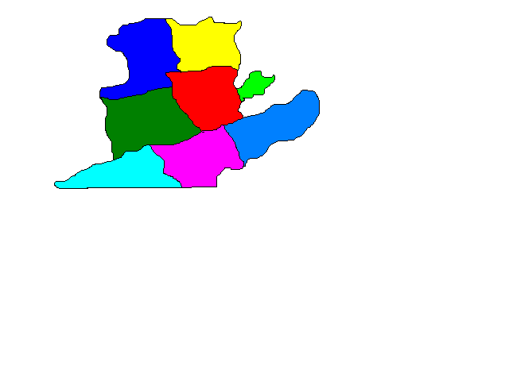 New River Valley Regional Jail

P.O. Box 1067

Dublin, Virginia 24084

(540) 643-2000 (540) 643-2010 FAX

Gregory P. Winston

Superintendent

NOTICE OF AWARD

May 4th, 2022

RFP NUMBER: 2022-02

TITLE: INMATE COMMISSARY SERVICES

AWARDED TO: OASIS MANAGEMENT SYSTEMS

The New River Valley Regional Jail Authority appreciates all qualified bidders for participating in this procurement process. Please feel free to contact us with any questions.